
Mission Interpretation
Telling stories of our hands doing God’s work

Mission Memo #512

January 20, 2021


Third Sunday after Epiphany (January 24,2021)
As we continue through the time after Epiphany, stories of the call to discipleship show us the implications of our baptismal calling to show Christ to the world. Jesus begins proclaiming the good news and calling people to repentance right after John the Baptist is arrested for preaching in a similar way. Knowing that John was later executed, we see at the very outset the cost of discipleship. Still, the two sets of brothers leave everything they have known and worked for all their lives to follow Jesus and fish for people.
Readings
- Jonah 3:1-5, 10 - Repentance at Nineveh
- Psalm 62:5-12 - God alone is my rock and my salvation. (Ps. 62:6)
- 1 Corinthians 7:29-31 - Living in the end times
- Mark 1:14-20 - The calling of the disciples at the sea
-----------------
When Saying Yes Requires Saying No
It was one of those thought-for-the-day-calendars you find in your Christmas stocking. The sayings mostly were trite and pithy, but every so often there was a truth worth repeating, for example: “Decide what you want and what you are willing to exchange for it. Set your priorities and go to work.” In other words, if we’re serious, saying yes to one thing often requires saying no to something else.
Jonah—after fleeing from the mission to which God was calling him (and three days and nights in the belly of the fish!)—now says “No!” to his former urges and “Yes!” to God as he sets out as God’s prophet to Nineveh. Paul invites us to say “No!” to trivial matters and “Yes!” to the things of God that have serious and eternal consequences. Jesus calls the disciples to say “No!” to their boats and nets and families and much of everything else they have known and to say “Yes!” to his “Follow me and I will make you fish for people.”
We feel a kinship with Jonah’s situation, because he struggles. He runs away from God and only relents after a huge fish vomits him onto a distant shore. The call-response stories of Simon, Andrew, James, and John make it all seem so easy. One little word of invitation from Jesus and these men turn in an instant from fishers to disciples.
But most of us live somewhere in the middle, not resisting God’s call with the vigor of Jonah but certainly responding more slowly and ambiguously than the disciples. So a question for today is: To what is God calling us to say “No!”? Remember, it’s not just the ugly stuff but often good things that must be denied for the sake of following Jesus. And then we must also ask in faith: To what is Jesus inviting us to say “Yes!”?
-----------------------------------------
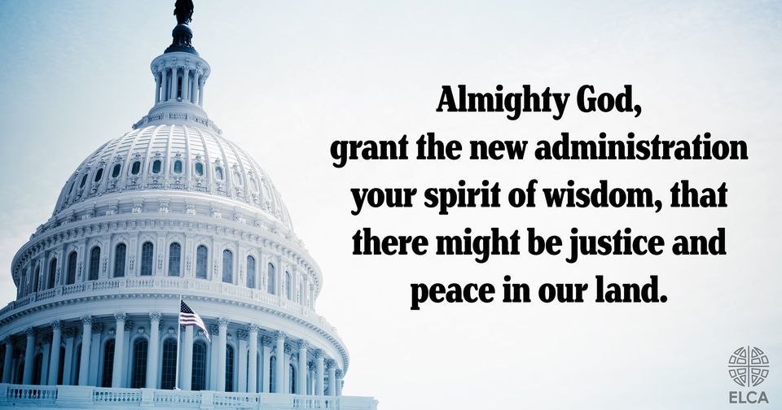
A Prayer for the new administration
Almighty God, we lift before you all who govern this nation. May those who hold power understand that it is a trust from you to be used, not for personal glory or profit, but for the service of the people. Drive from us cynicism, selfishness, and corruption; grant in your mercy just and honest government; and give us grace to live together in unity and peace; through Jesus Christ our Lord (ELW, p. 77).

The Week of Prayer for Christian Unity

At least once a year, Christians are reminded of Jesus’ prayer for his disciples that “they may be one so that the world may believe” (see John 17.21). Hearts are touched and Christians come together to pray for their unity. Congregations and parishes all over the world exchange preachers or arrange special ecumenical celebrations and prayer services. The event that touches off this special experience is the Week of Prayer for Christian Unity.
WHEN: Traditionally the week of prayer is celebrated between 18-25 January, between the feasts of St Peter and St Paul. In the southern hemisphere, where January is a vacation time, churches often find other days to celebrate it, for example around Pentecost, which is also a symbolic date for unity.
In order to prepare for the annual celebration, ecumenical partners in a particular region are invited to produce a basic liturgical text on a biblical theme. Then an international editorial team of WCC and Roman Catholic representatives refines this text to ensure that it can be prayed throughout the world, and to link it with the search for the visible unity of the church.
https://www.oikoumene.org/resources/week-of-prayer-for-christian-unity

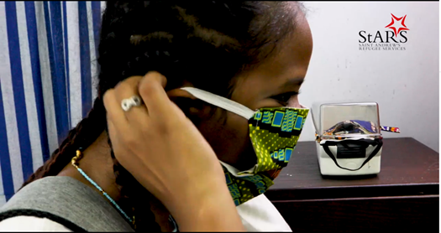
See Lutheran Disaster Response at work - StARS COVID-19 Response
During the COVID-19 pandemic, LDR is supporting St. Andrew's Refugee Services in Cairo, Egypt. StARS is providing for the refugee community through cash grants, food and hygiene kits, and continuing educational and psychological counseling programs over telephone. View the video at https://www.facebook.com/ELCALDR/videos/2694466210782846

Sad News from North Dakota
In part due to economic impacts from the pandemic and earlier actions, Lutheran Social Services of North Dakota — a non-profit agency with predecessor organizations dating to 1919 — has suspended programs and issued layoffs as part of a controlled liquidation plan.

The agency’s Board of Directors, after accepting reports from staff leadership, external advisers and legal counsel, passed a resolution that confirms actions leading to a liquidation, including a bankruptcy filing, if necessary.
The decision was driven in large part by continued struggles of Lutheran Social Services Housing, an affiliated program. LSS Housing, which started in 2009, impacted agency reserves and resulted in negative cash flow projections, according to Bob Otterson, who started Dec. 1, 2020, as the agency’s president and chief executive officer.
“LSS Housing in recent years has been draining the reserves of the affiliated agency,” Otterson said. “This financial pressure has hampered the ability of an essential, faith-based organization to serve its clients, specifically those in primary mission areas such as services to children, families, seniors and others.”
The action affects employment of 283 full-time and part-time staff and several long-term contractors. Click here to read more.

 | Event/Activity | Resources
Feb 11, 2021, 6:30pm - 8:00pm (Central ) | “Confronting Christian Zionism as Faithful Witness” presented by the Working Group on the Middle East | Register by February 10th at: https://us02web.zoom.us/meeting/register/tZcoceygrz4vGtzrgpEDjEzM8Vyn3PetcyWE
Feb13, 2021, 9 AM-4 PM | Lutherdale’s Second Annual Fabric Frenzy - quality fabrics at discount prices! | For more information visit https://www.lutherdale.org/programs/upcoming-events/
June , 2021 | Mission Moments - 33rd Annual Synod Assembly of the Metropolitan Chicago Synod, a virtual event | For more information visit http://www.mcselca.org/assembly/
August 3-5, 2021 | The Eleventh Triennial Convention of Women of the ELCA, Phoenix, Ariz | For more information visit https://www.womenoftheelca.org/eleventh-triennial-convention
August 14, 2021 | 35th Annual Lutherdale Fest Quilt Auction | For more information visit https://www.lutherdale.org/
July 24-28, 2022 | ELCA Youth Gathering - Boundless: God Beyond Measure, Minneapolis, MN | https://www.elca.org/YouthGathering/COVID19
August 8- 13, 2022. | 2022 Churchwide Assembly  Columbus, OH at the Greater Columbus Convention Center | For more information check  www.elca.org

