
Mission Interpretation
Telling stories of our hands doing God’s work

Mission Memo #514

February 2, 2021

Fifth Sunday after Epiphany (February 7,2021)

In Isaiah the one God who sits above the earth and numbers the stars also strengthens the powerless. So in Jesus’ healing work we see the hand of the creator God, lifting up the sick woman to health and service (diakonia). Like Simon’s mother-in-law, we are lifted up and healed to serve. Following Jesus, we strengthen the powerless; like Jesus, we seek to renew our own strength in quiet times of prayer.
Readings
- Isaiah 40:21-31 - The creator of all cares for the powerless
- Psalm 147:1-11, 20c - The Lord heals the brokenhearted. (Ps. 147:3)
- 1 Corinthians 9:16-23 - A servant for the sake of the gospel
- Mark 1:29-39 - The healing of Peter’s mother-in-law
-----------------
God Heals Persons and Communities
When Jesus heals us, we are empowered to serve others. While at first glance it might seem that Jesus’ healing of Peter’s mother-in-law was self-serving, on further reflection we see the same result in nearly all of his signs and miracles. The object of Jesus’ compassion now has new responsibilities. In the very next chapter a paralytic lowered through the ceiling is raised, only to become the center of a religious controversy (Mark 2:3-12), as was the man who lay by the pool of Beth-zatha for thirty-eight years (John 5:2-15). When Jesus calms the storm (Mark 4:35-41) the disciples have to row the rest of the way! Any meaningful encounter with Jesus will result in our being changed, which in turn alters the way we see our relationship to the needs of others and the world.
Hard economic times, natural disasters, and divisive, party strife can make us feel helpless and hopeless, as if we have been abandoned by God. Even the church—local congregations as well as denominations—may feel fear and panic in the face of declining numbers and revenues, loss of loyalty from members, indifference or hostility from the surrounding culture, and internal sniping among factions. The exiled people of Israel in Babylon experienced all of this and more, so our condition is neither unique nor beyond the reach of our God. Isaiah 40:21-31 in the NRSV begins “Have you not known? Have you not heard?” Eugene Peterson, in The Message, translates this idea as “Have you not been paying attention? Have you not been listening?” There is some irony indeed that God’s church, entrusted with God’s salvation history and the gospel, still panics, still doubts and worries, still feels like it is up to us to save the church. We indeed are “clay jars” (2 Cor. 4:7)—carrying the message but not understanding, preaching salvation but not believing that God cares or will act to save. We live Isaiah 40 every day.
-----------------------------------------
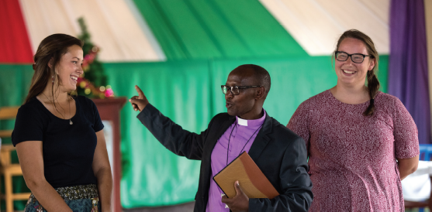
ELCA Young Adults in Global Mission cancels volunteer placement for 2021-’22
As the COVID-19 pandemic continues to cause uncertainty within the United States and across the globe, the Evangelical Lutheran Church in America (ELCA) has decided to cancel sending Young Adults in Global Mission (YAGM) volunteers for its 2021-22 program year. The pandemic earlier forced the ELCA to cancel volunteer placement for the 2020-21 program year. Cancellation two years in a row has never before happened in the 20-year history of the program. Young Adults in Global Mission is an international mission opportunity for young people from the ages of 21 to 29 in which volunteers live and serve with ELCA companion churches and partner organizations around the world.
In a letter to the 2021-22 applicants, Dan Beirne, program director for Young Adults in Global Mission leadership formation, wrote, “As we as a global community continue to respond to the lasting impacts of COVID-19, the rise of variants, and uncertainty surrounding vaccine rollout, it is becoming more and more evident that pursuing a year of service would present too many risks and unknown variables. We cannot move ahead with our normal processes when this many unknowns remain.”
Beirne also emphasized the impact on global companions who host the volunteers in their homes, churches and communities: “With all of this uncertainty, it would likely place an undue burden on these companions of ours to have them ‘set the table’ for a new group of volunteers when they may very well still be recovering, or actively struggling, themselves. As you know, we hold closely the value of accompaniment, where we seek to walk alongside our partners and share in life's joys and life's burdens. In this unique case, ‘walking alongside’ means keeping our distance.”
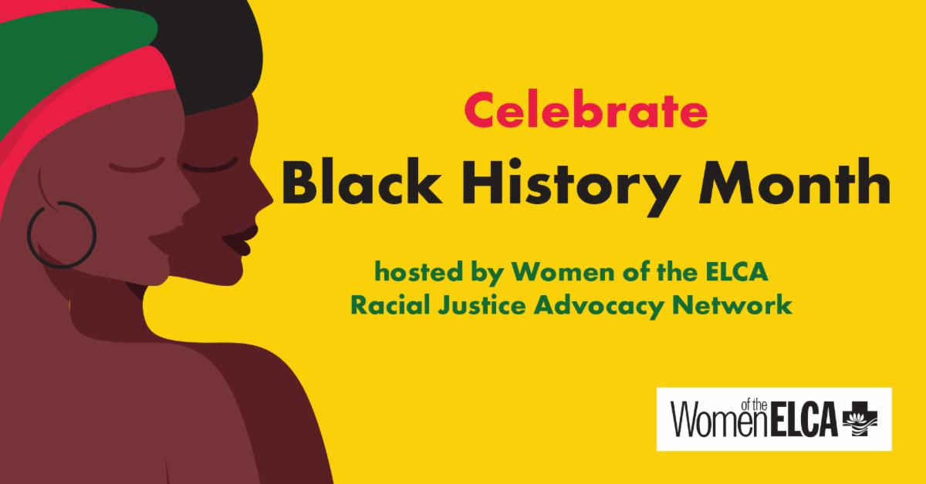
Join Women of the ELCA’s Racial Justice Advocacy Network for a conversation series celebrating Black History Month. Hear from four leaders in our church representing diverse specialties. They will share how being an African American woman in the United States influences their work and faith.
Watch via Facebook live on Tuesdays at 6:30 p.m. CST after joining our Racial Justice Advocacy group. Mark your calendars today.
Speakers and schedule:
Feb 9: Apu Seyenkulo, Doctor of Physical Therapy, Charlotte, N.C.
Feb 16: Linda Thomas, Ph.D., professor of Theology and Anthropology, Lutheran School of Theology, Chicago, Ill.
Feb 23: Antoinette Butler, music director, Shekinah Chapel, Chicago Ill.
March 2: The Rev. Nicolette Marie Peñaranda, MBA, M.Div., pastor at First Lutheran Church of the Trinity, Bridgeport, Ill., and candidate for alderman, Berwyn, Ill.
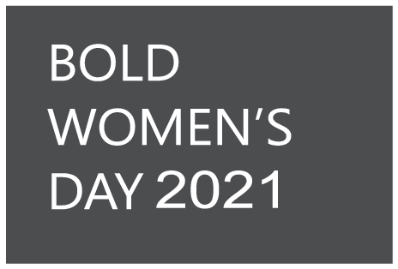
How will you celebrate Bold Women's Day?
Bold Women’s Day—observed annually on the fourth Sunday of February—celebrates all Lutheran women who have acted or are acting boldly on their faith in Jesus Christ.
But this year is different. Most congregations are not meeting in person, and that's where you come in. Please, tell us how you are promoting and celebrating Bold Women's Day, Feb. 28, in this COVID-19 time. We want to share your ideas with others.
Access Bold Women's Day resources here.
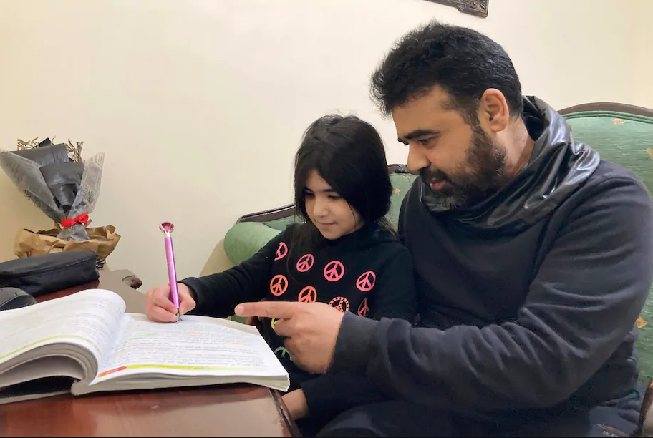
US refugee program aims to return stronger
"Krish Vignarajah has been in survival mode for years as the Trump administration slashed refugee admissions by 85%. She’s had to close a third of her resettlement agency’s 48 offices and lay off more than 120 employees, some with decades of experience. Now, she’s scrambling to not only rehire staff but to double the capacity of Lutheran Immigration and Refugee Service, an expansion not seen since the agency scaled up for the wave of refugees that arrived after the fall of Saigon in 1975."
LIRS CEO Krish O'Mara Vignarajah was recently featured in an article in the Washington Post discussing the need for refugee resettlement agencies to quickly rebound and rebuild under a more welcoming Biden administration. Click here for the article.

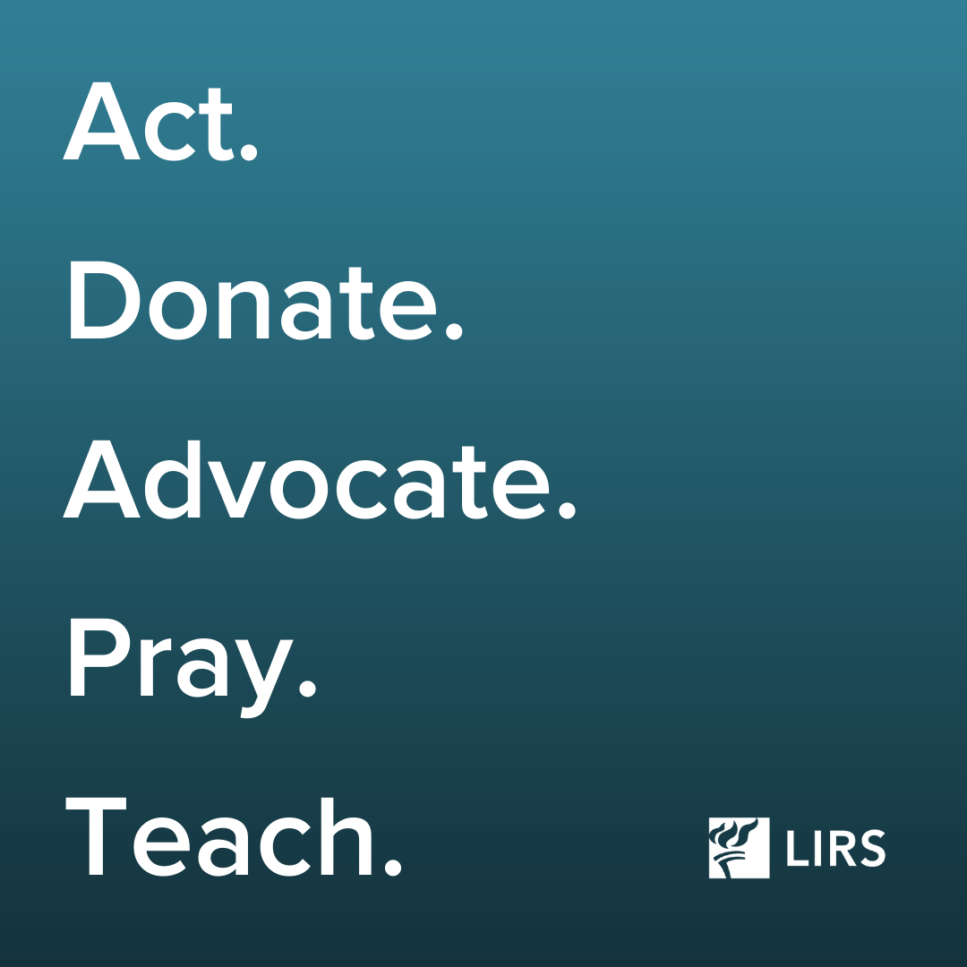
REMINDER: TAKE ACTION! As we enter a new era in immigration policy, we want you to join us in the work of welcome. Our Hope Rising Toolkit will provide you and your community with concrete ways to prepare for changes to the United States immigration system in the next 90 days (and beyond).
Download the toolkit.
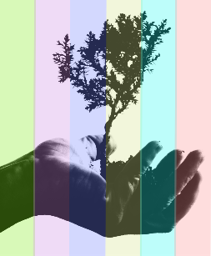
SAVE THE DATE
We are pleased to announce that the 2021 Metropolitan Chicago Synod, ELCA, Synod Assembly will be taking place virtually, June 5, 2021. This year's theme will be "Good Stewards."
More information about the assembly will soon be arriving in your inbox and on the MCS website.

 | Event/Activity | Resources
Feb 11, 2021, 6:30pm - 8:00pm (Central ) | “Confronting Christian Zionism as Faithful Witness” presented by the Working Group on the Middle East | Register by February 10th at: https://us02web.zoom.us/meeting/register/tZcoceygrz4vGtzrgpEDjEzM8Vyn3PetcyWE
Feb13, 2021, 9 AM-4 PM | Lutherdale’s Second Annual Fabric Frenzy - quality fabrics at discount prices! | For more information visit https://www.lutherdale.org/programs/upcoming-events/
June 5, 2021, 8:30 – 12:00 | Good Stewards - 33rd Annual Synod Assembly of the Metropolitan Chicago Synod, a virtual event | For more information visit http://www.mcselca.org/assembly/
August 3-5, 2021 | The Eleventh Triennial Convention of Women of the ELCA, Phoenix, Ariz | For more information visit https://www.womenoftheelca.org/eleventh-triennial-convention
August 14, 2021 | 35th Annual Lutherdale Fest Quilt Auction | For more information visit https://www.lutherdale.org/
July 24-28, 2022 | ELCA Youth Gathering - Boundless: God Beyond Measure, Minneapolis, MN | https://www.elca.org/YouthGathering/COVID19
August 8- 13, 2022. | 2022 Churchwide Assembly  Columbus, OH at the Greater Columbus Convention Center | For more information check  www.elca.org

