
Mission Interpretation
Telling stories of our hands doing God’s work

Mission Memo #517

February 23, 2021

Second Sunday in Lent (February 28,2021)

The second covenant in this year’s Lenten readings is the one made with Abraham and Sarah: God’s promise to make them the ancestors of many, with whom God will remain in everlasting covenant. Paul says this promise comes to all who share Abraham’s faith in the God who brings life into being where there was no life. We receive this baptismal promise of resurrection life in faith. Sarah and Abraham receive new names as a sign of the covenant, and we too get new identities in baptism, as we put on Christ.
Readings
- Genesis 17:1-7, 15-16 - God blesses Abraham and Sarah
- Psalm 22:23-31 - All the ends of the earth shall remember and turn to the Lord. (Ps. 22:27)
- Romans 4:13-25 - The promise to those who share Abraham’s faith
- Mark 8:31-38 - The passion prediction
-----------------
Promises, Promises
The story of God’s relationship with God’s people is a story of promises fulfilled. We hear about God’s covenant with Sarah and Abraham in today’s Genesis reading and. “Kings of peoples” (Gen. 17:16) descended from Sarah’s offspring; Jesus Christ, the King of kings, is Lord of all through his death and resurrection.
From generation to generation, God is steadfast. No matter how many ages pass or how often we turn away, God remains faithful. about its fulfillment in the New Testament texts. As Paul reminds us in Romans, we are the multitude of nations that were promised to Abraham; we are his descendants in faith This is the great hope of our faith—no matter how often we stray or how great our sin, God persists in loving us. Jesus Christ binds us to God through our baptism into his death. In worship—especially through confession, affirmation of baptism, and communion—we continually remember the lengths to which God goes to keep covenant with us. The promise of salvation extends even into the future, as the psalmist reminds us: Our children and our children’s children will proclaim God’s salvation to generations yet unborn.
-----------------------------------------
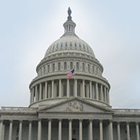
WHITE HOUSE OFFICE OF FAITH-BASED AND NEIGHBORHOOD PARTNERSHIPS – On Feb. 14, relaunching of a White House Office of Faith- Based and Neighborhood Partnerships by signing of an executive order was announced by the White House. The Washington Interreligious Staff Community including the ELCA signed a Jan. 21 letter requesting the entity’s reestablishment. ELCA staff look forward to meeting with the new Executive Director, Melissa Rogers, on February 19.
The letter read in part: “The voice of the faith community provides an important component in the deliverance, planning and implementation of policy and can inform the writing of legislation. People of faith see engagement with government as a fundamental part of the workings of democracy. The work of government must be wise and compassionate as it pursues policies for the common good. Engagement with the faith community enhances the work of government and enables it to be better informed on decisions to be made.”

POLICY RESPONSE TO COVID-19 IMPACTS CONTINUES: ELCA advocacy staff is analyzing the new Biden Administration and congressional activity for the new round of COVID-19 legislation while working to ensure that minoritized groups and Native American nations are an important focus in light of our understandings of the disproportionate health and economic impacts the pandemic has had on those of us historically and contemporarily impacted adversely by systemic racism. An open letter to Congress from the Circle of Protection, which the ELCA is part of, asked that the relief legislation addresses the “concurrent crises of the pandemic, economic recession, and systemic racism.” Hill visits on COVID-19 relief are ongoing.
The ELCA Program Director for Housing and Human Services prepared a letter for House and Senate committees, compiling recommendations from multiple service provider partners. Distributed in early February, it highlights the need to invest more in rent relief and housing aid for the most vulnerable in our communities, the work of congregations to address homelessness, and the anticipated looming eviction crisis if Congress fails to act. Use the Action Alert to share your experiences and urge priorities as pressing policy decisions on the impact of the COVID-19 pandemic are made.

COVID-19: Until all are safe, no one is safe

(LWI) – “We have observed with deep concern that the access to the vaccines is unequal,” wrote the Lutheran World Federation (LWF) General Secretary Rev. Dr Martin Junge in an open letter to the leaders of the G7 countries. “Wealthy countries have secured their doses, sometimes in more quantities than they need, while other countries and their populations have inadequate or no access at all.”
The G7 leaders will meet online on 19 February to discuss joint efforts against COVID-19 and steps to rebuild the global economy. The meeting will be hosted by the Prime Minister of the United Kingdom and will include leaders from Canada, France, Germany, Japan, the European Commission and European Council.
“Unequal access to vaccines reveals once again the immense inequality in the world, now even exacerbated by COVID-19,” wrote the LWF General Secretary. “A global approach driven by ‘vaccine nationalism’ cannot work because until all are safe, no one is.” (MORE)

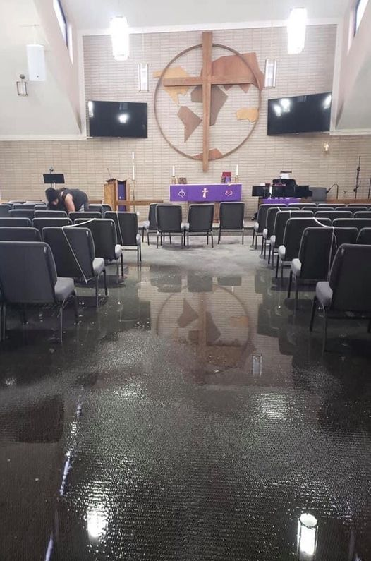
Lutheran Disaster Response to Winter Storms
Beginning Feb. 14, a polar vortex descended over the United States. It is responsible for subfreezing temperatures and heavy snow across the country, impacting millions of people. The harsh conditions severely impacted Southern states, such as Texas, which lack the infrastructure to handle the freezing temperatures and record-setting snow and ice. This has led to power, food and water shortages throughout the region. At the peak of power shortages, 4.5 million homes and businesses in Texas were without electricity and heat. Around 13 million Texans are also facing water disruptions due to bursting pipes and damaged water systems. As temperatures rise, melting ice and snow is expected to cause even more water damage. Lutheran Disaster Response is accompanying local ELCA synods and social ministry organizations in Texas to provide relief for those affected by the recent storms and to look ahead to long-term recovery. Here's how to help: https://community.elca.org/us-storms...

 | Event/Activity | Resources
June 5, 2021, 8:30 – 12:00 | Good Stewards - 33rd Annual Synod Assembly of the Metropolitan Chicago Synod, a virtual event | For more information visit http://www.mcselca.org/assembly/
August 3-5, 2021 | The Eleventh Triennial Convention of Women of the ELCA, Phoenix, Ariz | For more information visit https://www.womenoftheelca.org/eleventh-triennial-convention
August 14, 2021 | 35th Annual Lutherdale Fest Quilt Auction | For more information visit https://www.lutherdale.org/
July 24-28, 2022 | ELCA Youth Gathering - Boundless: God Beyond Measure, Minneapolis, MN | https://www.elca.org/YouthGathering/COVID19
August 8- 13, 2022. | 2022 Churchwide Assembly  Columbus, OH at the Greater Columbus Convention Center | For more information check  www.elca.org

